Candlewick News September 2019
From the Editor…
Welcome to the late summer Candlewick newsletter. Just a couple of updates, the most important of which being the invitation below to the Long Long Lunch on City Giving Day. If you haven’t already got tickets, act fast! All are welcome. There are also updates on two other issues relevant to the Ward – Bank Station and the ongoing roadworks in Cannon Street. I hope to see you on the 24th for the lunch.
James de Sausmarez
Common Councilman

The Long Long Lunch
Join us for the Long Long Lunch in support of the Lord Mayor’s City Giving Day on Tuesday, 24th September 2019.
Once again Hispania, 1 Lombard Street, The Don, Coq d’ Argent and Herbert Berger have put together a remarkable menu. Taittinger are providing the champagne, Trinity Hill are pouring the wines. Nespresso are serving us coffee.
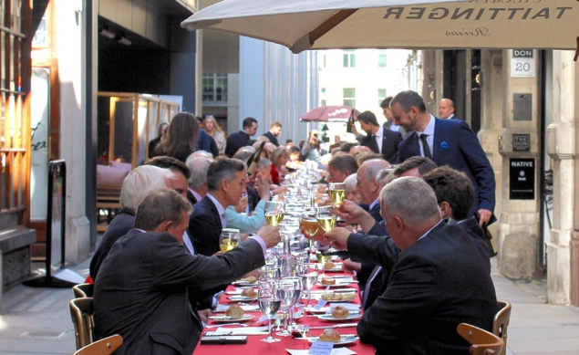
Champagne, canapés & a three course lunch with matching wines for £65 per person.

The running order for the day is:
12:15 Champagne and Canapés in St. Stephens Walbrook Church with pianist Rimantas Vingras
13:00 Long Long Lunch to start in St. Swithin’s Lane
Menu
Canapés by Hispania & Champagne Taittinger Brut
Red Mullet Boudin, celeriac remoulade, lambs lettuce & keta caviar vinaigrette – by 1 Lombard Street
Trinity Hill Sauvignon Blanc 2016
Roast Breast of Corn-Fed Chicken, creamy potatoes, Autumn vegetables and truffle supreme sauce – by The Don
Hawkes Bay Trinity Hill Merlot 2014
Pomme Rouge, red apple parfait – by Coq D’Argent
Assorted Macaroons – by Herbert Berger at Innholders Hall
Nespresso Grand Cru
Book at: longlunch@thedonrestaurant.co.uk
or call 0207 7626 2606

Cannon Street Roadworks Update
Just a short update on the gas works by Cadent in Cannon Street.

Cadent have now abandoned over 170m of gas main and have nearly finished lining the 18” main along the north side of Cannon St from Queen Victoria St. These works have so far presented a few unexpected problems, including several bends, connections and other utility services affecting the progress outside Cannon Street station, but ‘sleeving’ the next section (Walbrook to Abchurch Lane) has started and overall completion of the project is still expected around October.

The need to undertake these replacement works was also underlined last week when a section of the remaining network suffered a leak which required the temporary evacuation of nearby buildings as gas entered various adjacent basements.

Underground camera surveys have identified where excavations are needed in the next phase east from Cannon St station, and works to connect the new mains into those installed last year at the London Bridge junction are being co-ordinated with TfL’s Bank Station Upgrade site team at 110 Cannon St.

Finally, City Corporation officers continue to monitor the network with colleagues at Transport for London, adjusting signals and signage as appropriate, but traffic seems to be coping well.

Bank Station Development
The Bank Station Capacity project successfully hit their half way mark in early July and is on programme for completion in late 2022. This project involves the building of a new southbound tunnel for the Northern Line from Bank to London Bridge and the creation of a new northbound tunnel from the two existing tunnels. It also entails the creation of a new Bank station exit in Cannon Street. Some current project headlines are as follows:
- Currently on target to complete the works in 2022.
- More than 1000m of new tunnels have been built. Construction of the new escalator barrels are next.
- Waterproofing of the new tunnels has started, including the new Central line moving walkway link.
- The top down excavation, where the new entrance/exit on Cannon Street will be, is finished.
- The construction of a new lift shaft to provide direct, step-free access from street to both Northern line and DLR platforms has started.
Most importantly, in the Spring/Summer of 2021, there will be a Northern line closure between Moorgate and Kennington for 17 weeks. City Corporation Officers are continuing to work with London Underground on the exact timing and mitigation measures. All your representatives are taking a close interest in this and particularly the mitigation measures proposed. If you have any concerns, then please do speak to any one of us.
Contact Us
To get in touch with the Candlewick team, please use the details below:
Alderman Emma Edhem
emma.edham@cityoflondon.gov.uk

Kevin Everett, CC Deputy
kevin.everett@cityoflondon.gov.uk
07771 783265

James de Sausmarez, CC
james.desausmarez@cityoflondon.gov.uk 0207 818 3349

